Tel Aviv University
Faculty of Engineering — School of Electrical Engineering
Final Engineering Project Report — Project No. 3221

Optical Fibers for Smart Cities
IoT-Enabled Fiber-Optic Sensing for Real-Time-Capable Vehicle Tracking and Road-Anomaly Detection
Students
Noa Sapir · Nitai Dobrecki
Project Instructor
Khen Cohen
Academic Year 2025–2026

Table of Contents
Abstract 4
1 Introduction 6
1.1 Goals of the project 6
1.2 Motivation 6
1.3 Approach 6
1.4 Comparison with existing work 6
2 Theoretical Background 8
2.1 Distributed Acoustic Sensing 8
2.2 Vehicle-induced ground response 8
2.3 Multi-sensor fusion and the Kalman filter 8
2.4 Anomaly detection without labels 9
2.5 Alternative algorithms considered 9
3 Simulation and System Design 10
3.1 Simulation environment and architecture 10
3.2 Vehicle motion model 11
3.3 Sensor models 11
3.4 Scenario generation 12
3.5 Simulation outputs and workflow 12
3.6 Assumptions and limitations 13
4 Implementation 14
4.1 Software architecture 14
4.2 End-to-end information flow 14
4.3 Communication and dependencies between modules 15
4.4 Ground-truth separation and data integrity 15
4.5 Key algorithms and engineering decisions 16
4.6 The anomaly model in detail 16
4.7 Repository structure 18
5 Analysis of Results 19
5.1 Tracking and fusion accuracy 19
5.2 Sensor contribution and fusion behavior 21
5.3 Anomaly-detection performance 21
5.4 Missed anomalies and failure analysis 24
5.5 Comparison with quantitative targets 24
6 Conclusions and Further Work 26
6.1 Results against the original goals 26
6.2 Suggestions to improve performance 26
6.3 Future development and research 26
7 Project Documentation 27
7.1 Software 27
7.2 Simulations and datasets 27
7.3 Documentation contents and location 27
8 References 28

List of Figures
Figure 1: System block diagram 5
Figure 2: The modeled urban intersection scene (DAS, camera, GPS, fused track) 10
Figure 3: Real urban road network imported from OpenStreetMap (North Tel Aviv) 11
Figure 4: The 144 simulation regions used to build the normal baseline 12
Figure 5: End-to-end information flow through the system 14
Figure 6: Anomaly-detection model architecture 17
Figure 7: Fused multi-sensor track vs. ground truth (RMSE = 0.49 m) 20
Figure 8: Continuous tracking across three connected segments (RMSE = 0.37 m) 21
Figure 9: Anomaly score of the injected vehicle per scenario 22
Figure 10: Per-vehicle Z-score ranking (over-speeding scenario) 23
Figure 11: Top anomalous features vs. the normal training distribution 24
List of Tables
Table 1: Sensor measurement models 11
Table 2: Feature groups produced by the feature extractor 18
Table 3: Anomaly-detection results across nine injected scenarios 22
Table 4: Quantitative performance targets and achieved results 25
List of Equations
Equation 1: DAS strain-rate measurement 8
Equation 2: Flamant–Boussinesq strain amplitude 8
Equation 3: Kalman state vector 8
Equation 4: Kalman prediction step 8
Equation 5: Kalman update step 9
Equation 6: DAS detection probability 11
Equation 7: SNR-driven dynamic measurement noise 16
Equation 8: Normalized Innovation Squared (NIS) 16
Equation 9: Page's CUSUM recurrence 18
Equation 10: Per-feature Z-score anomaly criterion 18
Equation 11: Position RMSE 19

Abstract
Modern cities are laced with thousands of kilometers of telecommunication optical fiber. This project addresses a central research question: whether that existing fiber can be used as a distributed urban traffic sensor, and whether the resulting signals can be fused with conventional cameras and GPS to track vehicles and identify irregular driving behavior using only existing fiber infrastructure and complementary sensing modalities. The system is designed as a streaming, event-driven pipeline whose architecture supports real-time operation; in this work it is evaluated in an offline batch configuration, and full real-time latency profiling remains future work. To investigate this, we designed and built SimStudio, a complete desktop simulation, sensor-fusion, and anomaly-detection environment for fiber-optic Distributed Acoustic Sensing (DAS) [1], [2].
SimStudio imports real urban road networks from OpenStreetMap [9], drives physically grounded vehicles along them, and synthesizes three complementary sensing modalities: DAS strain on a buried fiber, vision-based camera detections, and satellite GPS fixes. An event-driven pipeline associates these heterogeneous measurements into stable vehicle tracks, fuses them through a six-state constant-acceleration Kalman filter [5], [8] with physically grounded, signal-to-noise-dependent measurement noise, and exports trajectories, error metrics, and diagnostics. A read-only analytics layer then extracts 166 behavioral features per vehicle and detects anomalies using an interpretable per-feature Z-score baseline, complemented by a Page CUSUM temporal detector [6] and an Isolation-Forest alternative [7].
The system met its two primary objectives. Fused tracking achieved sub-meter accuracy — a representative cross-segment track reached 0.49 m RMSE (mean 0.35 m across all evaluation scenarios), well within the project tolerance — and the anomaly model correctly identified the injected anomalous vehicle in six of nine scenarios, satisfying the work-plan target of detecting at least five of ten anomalies. The chapters below present the theory, system design, implementation, and results in full, and discuss how the approach can be extended with labeled data and richer DAS physics.
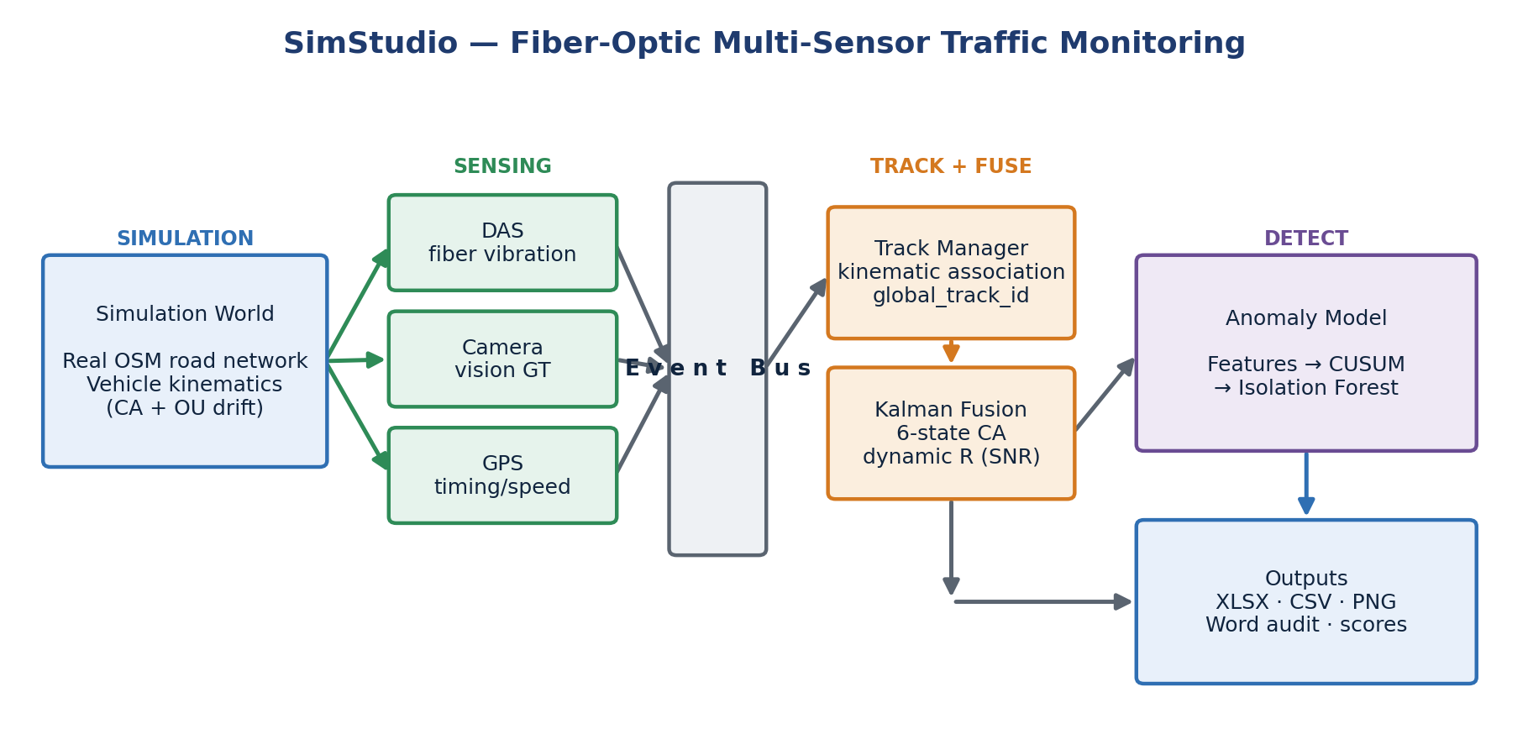
Figure 1: System block diagram — from the simulated world through multi-sensor sensing, the event bus, tracking and Kalman fusion, to anomaly detection and outputs.

1 Introduction
Urban mobility is under increasing strain. Authorities need continuous, low-cost knowledge of how vehicles move through a city and when something goes wrong — a sudden stop, a stalled car, a collision, or a wrong-way driver. Conventional monitoring relies on dense networks of cameras and inductive loops, which are expensive to install, costly to maintain, and degraded by adverse weather and darkness. This project pursues a complementary path: re-using the optical-fiber infrastructure already deployed beneath most streets.

1.1 Goals of the project
The project set out to build and validate a multi-sensor traffic-monitoring system with two primary objectives. First, reliable vehicle tracking across a monitored road network — maintaining a consistent identity and an accurate trajectory for each vehicle as it travels across multiple street segments, by fusing DAS, camera, and GPS measurements. Second, accurate anomaly detection — automatically identifying irregular and unsafe driving behavior, such as speeding, sudden braking, stalled vehicles, collisions, weaving, and tailgating, from the fused sensor signals.
Because dedicated DAS interrogator hardware and an instrumented street were not available within the project timeframe, both objectives were pursued through a physically grounded simulator that reproduces the measurement chain — from vehicle weight to fiber strain to a Kalman measurement — so that algorithms developed against it can transfer to real deployments with limited modification.

1.2 Motivation
Fiber-optic sensing offers properties that complement camera networks, particularly continuous spatial coverage over tens of kilometers from a single cable, robustness to lighting and weather, and low incremental hardware cost because the fiber already exists [1], [3]. Re-using a passive communication asset as a live urban sensor is attractive both scientifically — it advances multi-sensor spatiotemporal signal fusion — and economically, as a scalable route to city-wide situational awareness and faster emergency response.

1.3 Approach
Rather than treating any single sensor as authoritative, the system is built around complementary fusion. DAS provides dense, weather-independent position and along-fiber speed; cameras provide accurate but occlusion- and lighting-limited detections; GPS provides absolute position and timing but at low rate and accuracy. A Kalman filter weights each measurement by its physically derived uncertainty, so the estimate relies on whichever sensor is currently most trustworthy [5]. On top of the fused tracks, anomaly detection is framed as learning the distribution of normal driving across many scenarios and then measuring deviation from that norm — an approach that does not require the large labeled anomaly datasets that are scarce in this domain [7].

1.4 Comparison with existing work
Commercial DAS traffic systems such as OptaSense detect and classify vehicles on single road segments but lack multi-sensor integration and cross-street tracking. Camera-based platforms such as Miovision manage flow at intersections but remain constrained by weather and lighting. Academic work at Tel Aviv University has shown that DAS traffic signals can be learned from co-located video labels [1], [2], and a related study fuses DAS with computer-vision tracking through a Kalman filter [3]. This project extends that line of work by combining all three modalities — DAS, vision, and GPS — into a single cross-segment tracking and anomaly-detection framework, and by packaging it as a reproducible simulation environment that exposes every stage of the pipeline for inspection.

2 Theoretical Background

2.1 Distributed Acoustic Sensing
Distributed Acoustic Sensing transforms a standard telecommunication fiber into a dense array of vibration sensors [1], [2]. A laser pulse is launched into the fiber, and a small fraction is continuously back-scattered (Rayleigh scattering) by intrinsic density variations in the glass. Ground vibration stretches and compresses short fiber segments, shifting the optical phase of the back-scattered light. By comparing the phase between two points separated by a gauge length L, the interrogator recovers the local strain rate (Equation 1):
$ε̇(t,z) ≈ \frac{1}{L}\left[u̇(t,z+L) − u̇(t,z)\right]$ Equation 1
where u(t, z) is the ground displacement along the fiber. Each meter of fiber thus becomes an independent vibration channel, and a passing vehicle produces a characteristic moving signature whose amplitude encodes its weight and whose slope across channels encodes its speed.

2.2 Vehicle-induced ground response
A vehicle is a moving surface load. To first order, the quasi-static strain it induces at a buried fiber at perpendicular distance r follows a Flamant–Boussinesq-type decay (Equation 2):
$A = \frac{W}{{\left(r + d_{0}\right)}^{2}}$ Equation 2
where W is the vehicle weight and d₀ a small floor that keeps the amplitude finite directly above the cable. This relationship is doubly useful: it lets the simulator generate realistic DAS amplitudes, and it lets the analytics layer back-estimate vehicle weight from the measured amplitude — a feature later used for anomaly detection.

2.3 Multi-sensor fusion and the Kalman filter
The Kalman filter is a standard tool for recursive state estimation under linear-Gaussian assumptions [5], [8]. It maintains a Gaussian belief over a vehicle's kinematic state and alternates a predict step that propagates the state through a motion model and an update step that corrects it with each incoming measurement, weighted by the relative uncertainty of model and measurement. Because the update weight is the Kalman gain — large when the measurement is trustworthy, small when it is noisy — the filter naturally implements complementary fusion: a precise DAS or camera fix corrects the estimate strongly, while a noisy GPS fix only nudges it.
The project uses a six-state constant-acceleration model with decoupled x and y axes. The state vector (Equation 3) encodes position, velocity, and acceleration on each axis:
$x = {\left[x v_{x} a_{x} y v_{y} a_{y}\right]}^{T}$ Equation 3
The predict step propagates the state estimate and its covariance through the constant-acceleration transition matrix F and the process-noise covariance Q (Equation 4):
${x̂}_{k}^{−} = F {x̂}_{k−1}, P_{k}^{−} = F P_{k−1} F^{T} + Q$ Equation 4
When a measurement z arrives, the update step computes the Kalman gain K and corrects the state, with H the observation matrix and R the measurement-noise covariance (Equation 5):
$K = P_{k}^{−} H^{T}{\left(H P_{k}^{−} H^{T} + R\right)}^{−1}$ Equation 5

2.4 Anomaly detection without labels
Labeled real-world anomaly data — actual collisions, stalls, and reckless maneuvers recorded on DAS — is scarce. Supervised classifiers such as Random Forests or SVMs require many examples of both normal and anomalous behavior and are therefore impractical at this stage. The project instead adopts a one-class, unsupervised approach: learn the distribution of normal driving from many normal scenarios, then score each new vehicle by how far it deviates [7]. A Page CUSUM test [6] monitors the filter's Normalized Innovation Squared over time to indicate when a vehicle began behaving abnormally, while a per-feature Z-score baseline (with an Isolation Forest as an unsupervised alternative [7]) scores the whole trajectory to indicate whether a vehicle is anomalous overall. As labeled anomaly exports become available, the same feature pipeline can feed a supervised Random Forest, which the implementation already supports.

2.5 Alternative algorithms considered
Several alternative algorithms were evaluated for the fusion and detection stages before the final design was selected. Extended and Unscented Kalman filters handle nonlinear motion and measurement models, but the simulator's kinematics and the position/speed measurements are represented adequately by a linear constant-acceleration model, so the added complexity was not justified at this stage. Particle filters are more flexible for strongly nonlinear, non-Gaussian systems, but are computationally heavier and unnecessary given the near-Gaussian measurement noise produced by the sensor models.
Supervised classifiers such as Random Forest or SVM could improve anomaly recall, but they require a larger labeled anomaly dataset than was available; they are therefore retained as a future option rather than the primary detector. Deep-learning models are powerful for interpreting raw DAS waterfalls [2], but demand extensive labeled real data and offer less interpretability than the feature-based approach used here. Rule-based thresholds are simple and interpretable, but generalize poorly across traffic densities and sensor layouts. The chosen combination — a linear Kalman filter for fusion and an interpretable Z-score baseline for detection — was selected as the best balance of accuracy, interpretability, and data efficiency for the current project scope.

3 Simulation and System Design
This chapter describes the overall system design and the simulation environment that realizes it: the architecture and its rationale, the vehicle and sensor models, scenario generation, the simulation outputs and workflow, and the assumptions and limitations that bound the results.

3.1 Simulation environment and architecture
The system is organized as a one-directional pipeline of loosely coupled stages — simulate, sense, publish, track, fuse, export, analyze — connected by a shared event bus (Figure 1). The central design decision was this event-driven decoupling: the simulator publishes typed events (vehicle states and per-sensor measurements) onto the bus, and every downstream component consumes them independently. This approach was preferred over a monolithic design because it makes each sensor and consumer independently testable, lets the tracking, fusion, and analytics layers evolve without modifying the simulator core, and guarantees that the anomaly model remains strictly read-only.
Since dedicated DAS interrogator hardware and an instrumented road segment were not available within the project timeframe, the project focused on a physically grounded simulation environment. The simulator does not attempt to reproduce every optical detail of a DAS interrogator; instead it reproduces the observable quantities required by the tracking and anomaly-detection algorithms — sensor coverage, measurement uncertainty, detection gaps, DAS amplitude, and SNR-dependent noise. This makes the simulator suitable for controlled algorithm development and evaluation, and means the same feature-extraction and detection code can later be applied to recorded DAS data without modification.
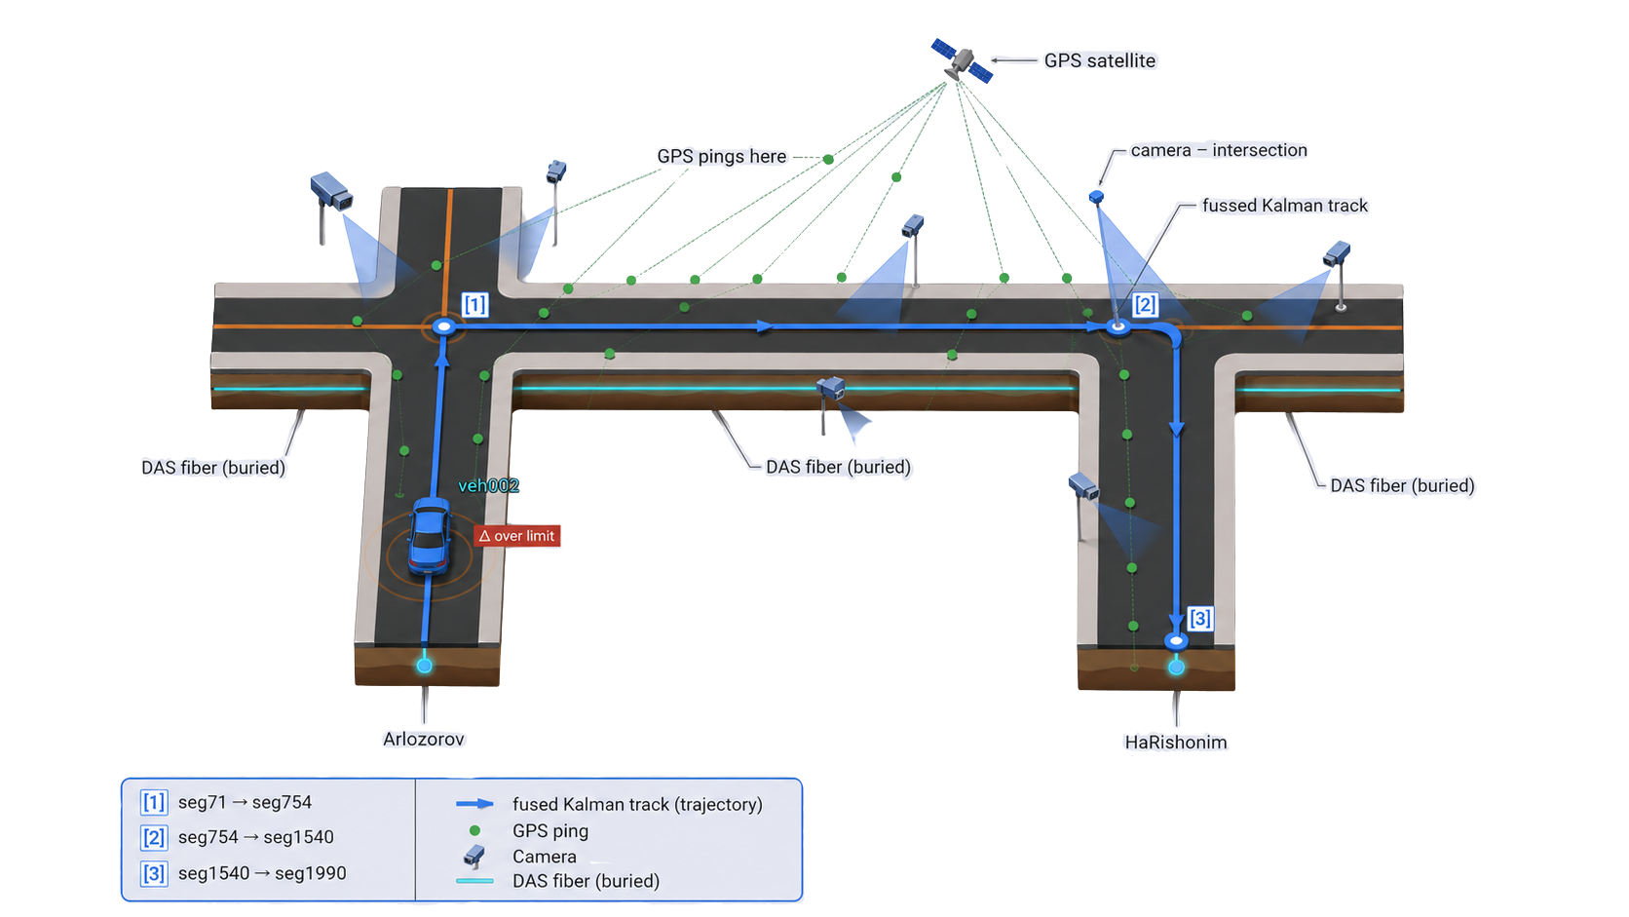
Figure 2: The modeled urban scene. A buried DAS fiber runs beside each road segment, cameras observe intersections, and GPS provides absolute fixes; the three modalities are fused into a single Kalman track as a vehicle crosses the junction.
The simulation engine advances a world of vehicles on a road network at 25 Hz. The road network is not synthetic: maps are imported from OpenStreetMap [9], so vehicles travel along real streets — for example the Florentin and northern Tel Aviv networks used in evaluation (Figure 3) — with true geometry, lane counts, and posted speed limits.
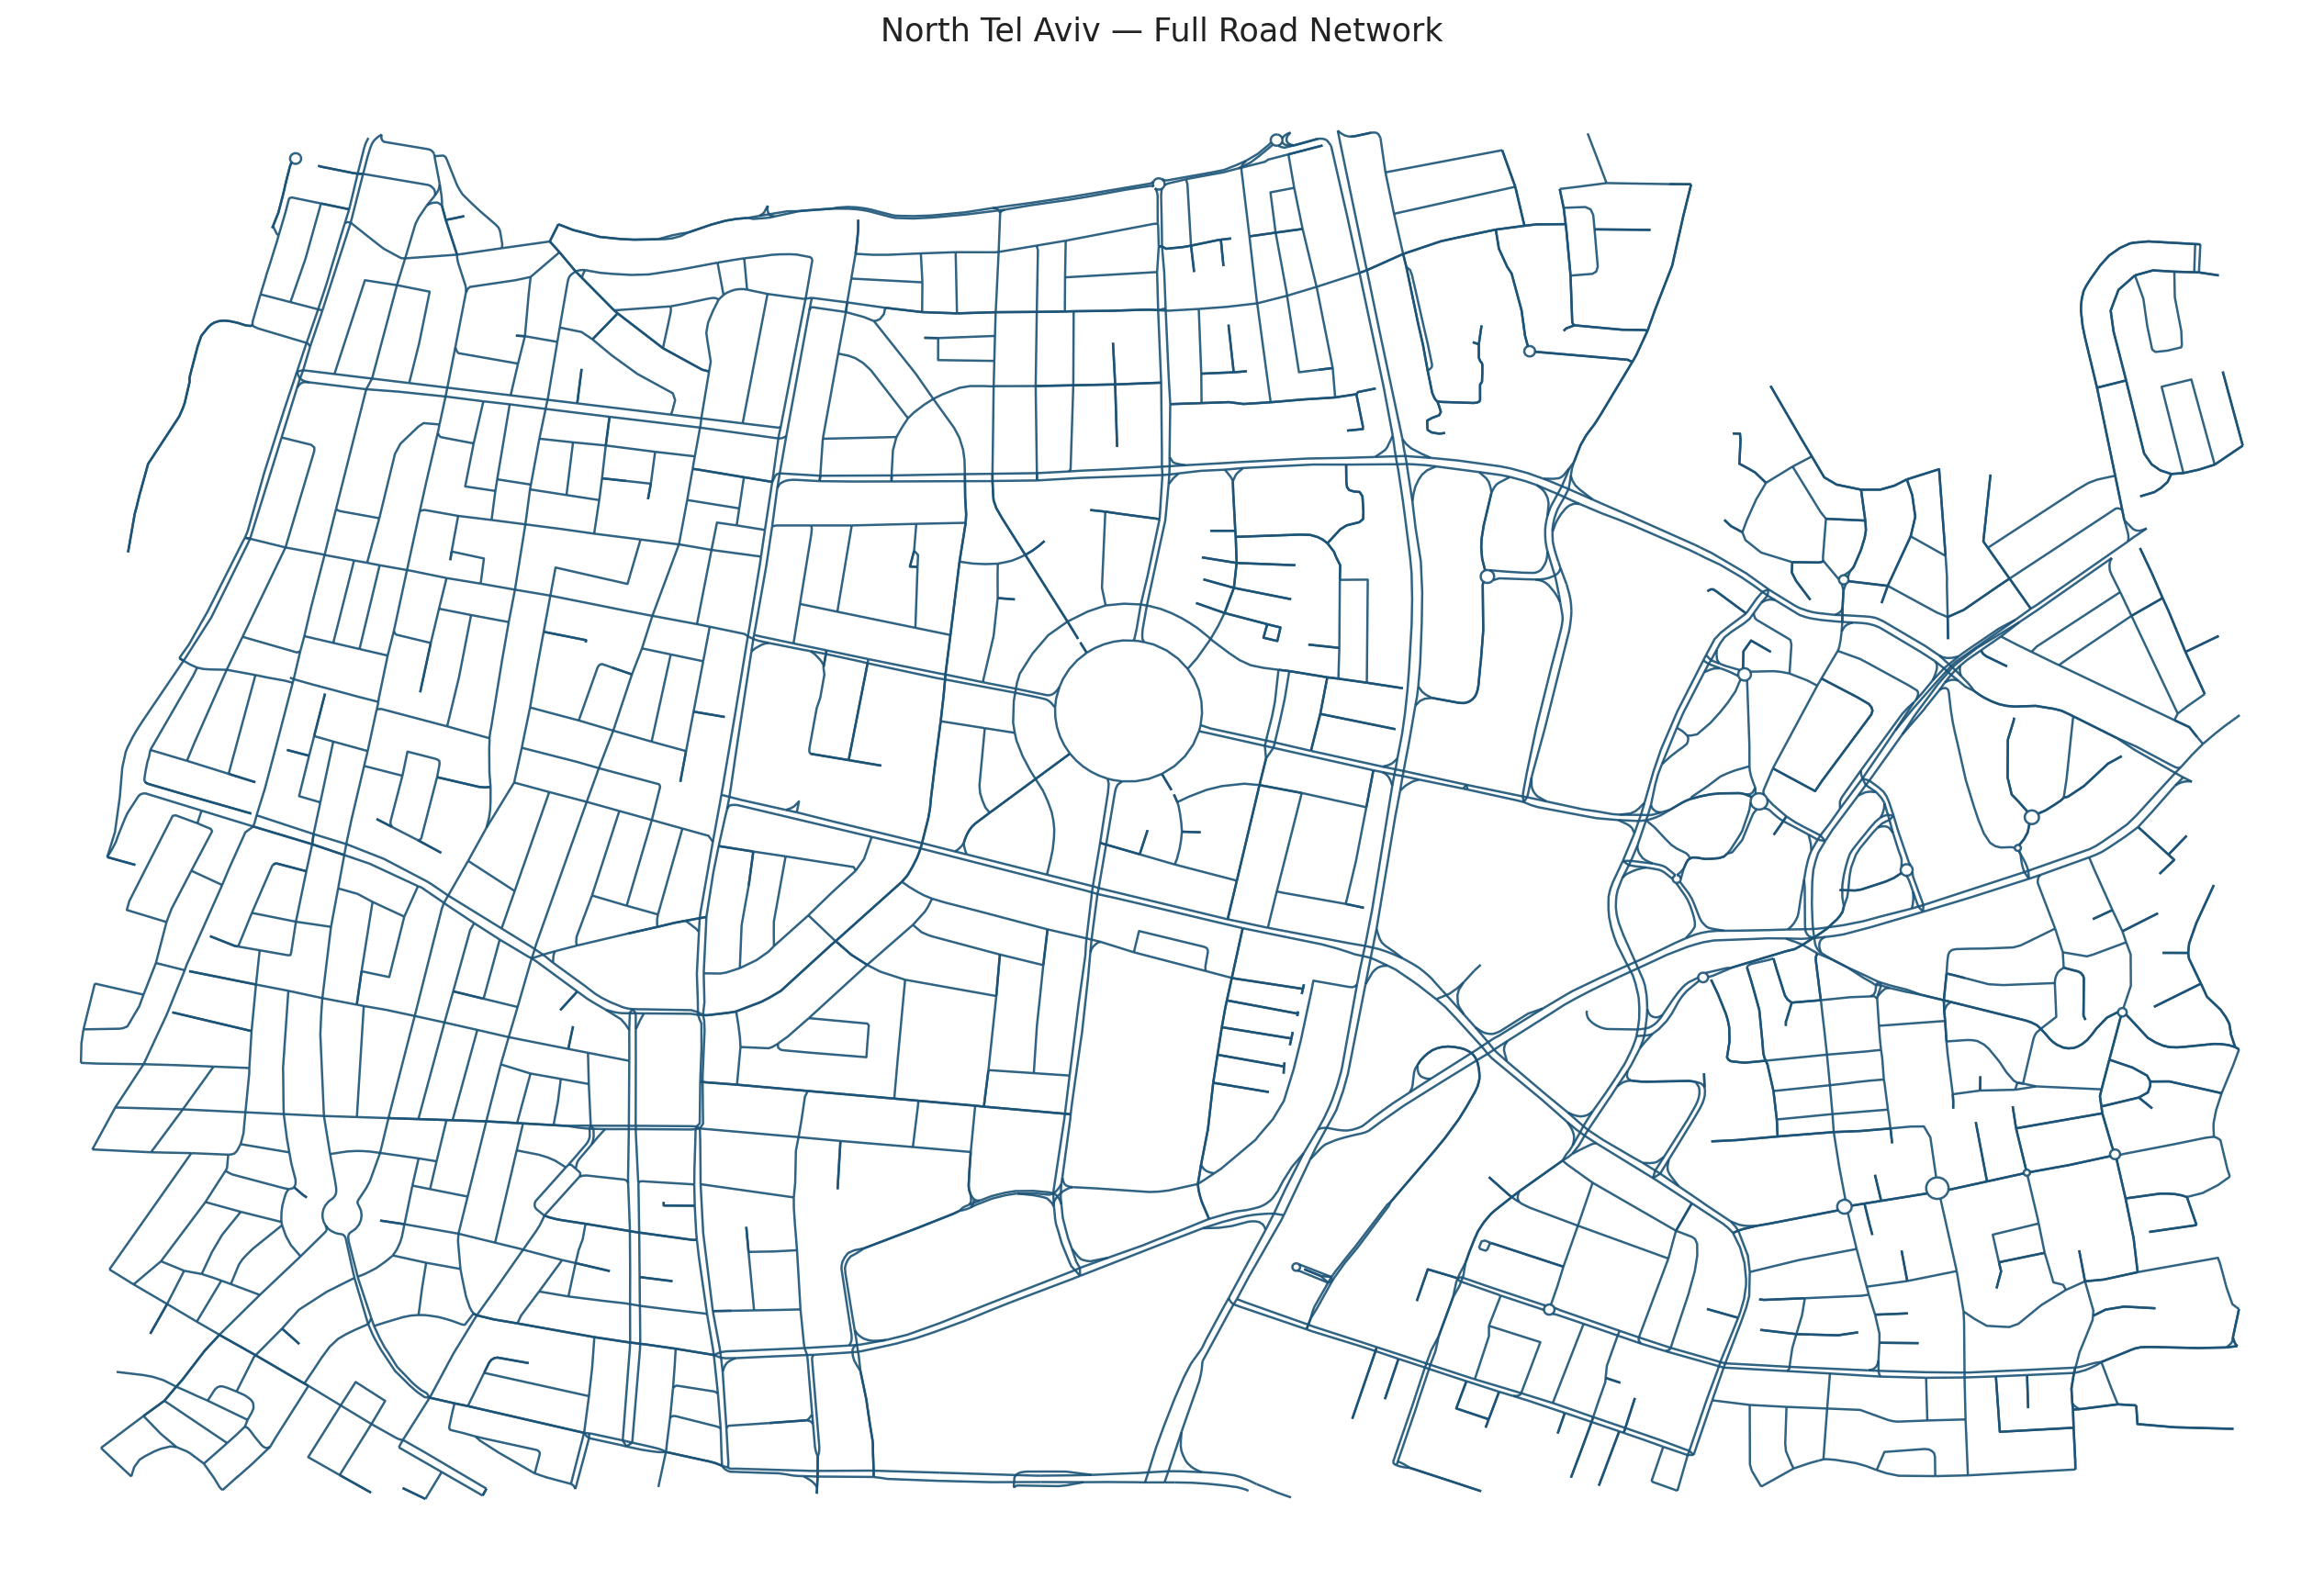
Figure 3: Real urban road network imported from OpenStreetMap (North Tel Aviv). Vehicles are simulated along true street geometry, lane counts, and speed limits.

3.2 Vehicle motion model
Each vehicle is modeled as a point mass on a lane centerline. Its longitudinal motion is driven by a first-order speed-tracking controller toward a stochastic macro speed profile resampled at intervals, producing realistic acceleration and cruise phases. Lateral position follows a mean-reverting Ornstein–Uhlenbeck process bounded to half a lane width, which reproduces natural lane-keeping wander. These ingredients were chosen to reproduce the slightly irregular motion that makes tracking and anomaly detection non-trivial, while remaining inexpensive enough to run hundreds of scenarios.

3.3 Sensor models
After each vehicle moves, the engine generates synthetic measurements from three sensor types (Table 1). The defining feature of all three is that their uncertainty is physically derived and forwarded to the Kalman filter, so fusion weighting is automatic.
Sensor | What it measures | Noise model (key idea) | Rate
DAS | Along-fiber position & speed | σ ∝ k/√SNR; SNR from weight & distance; detection gating, bias, peak-merging | ~25 Hz
Camera | World position (x, y) | Pinhole projection; floor + range + off-axis terms; stochastic FOV gating | ~ frame rate
GPS | Absolute position (x, y) | σ grows with range from sensor center; range-dependent confidence | ~1 Hz
Table 1: Sensor measurement models. Each sensor exposes a physically grounded uncertainty that the Kalman filter consumes directly.
DAS is modeled most richly because it is the project's novel modality. Vehicle weight sets the strain amplitude through the Flamant–Boussinesq law; the signal-to-noise ratio then governs both the probability that the vehicle is detected at all and the position uncertainty. Detection follows a sigmoid in SNR² — a vehicle at the threshold SNR is detected half of the time (Equation 6):
$p_{detect} = \frac{{SNR}^{2}}{{SNR}^{2} + t^{2}}$ Equation 6
The model also injects a small systematic peak-finding bias and merges the strain peaks of vehicles that are close along the fiber — two effects that mimic well-documented DAS artifacts and keep the simulated data faithful to the technology's limitations.

3.4 Scenario generation
To build a broad notion of normal driving, the northern Tel Aviv network was divided into 144 simulation regions (Figure 4). Each region seeds an independent traffic scene, and batch runs across the regions produce a large, varied corpus of normal behavior. The normal set deliberately spans twelve conditions — sparse to heavy traffic, heavy vehicles, stop-and-go, legal high speed, and sensor layouts from full coverage down to DAS-only — so that the anomaly baseline does not over-fit a narrow definition of normal. A separate set of nine scenarios each injects one anomalous vehicle drawn from eight anomaly categories, providing controlled positives for evaluation.
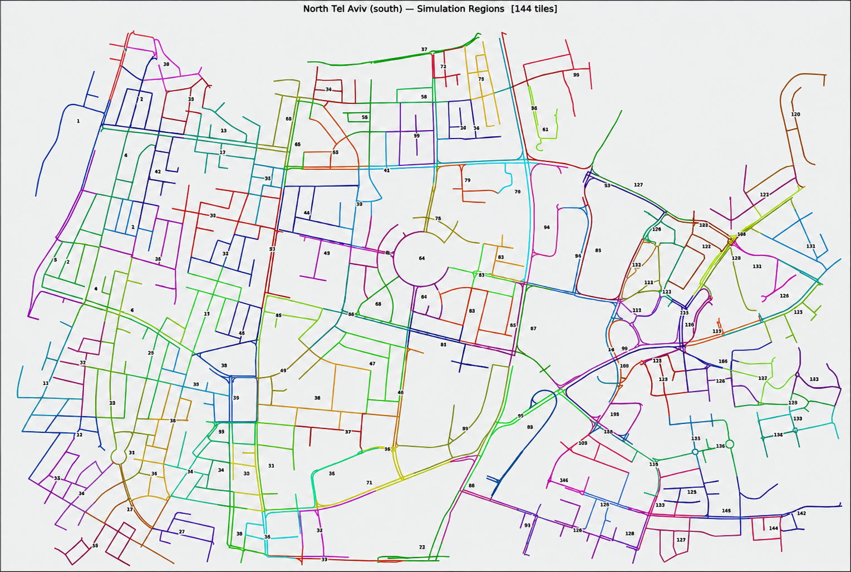
Figure 4: The northern Tel Aviv network divided into 144 simulation regions (tiles). Each region seeds an independent traffic scene; batch runs across them produce the varied corpus of normal behavior from which the anomaly baseline is learned.

3.5 Simulation outputs and workflow
The simulator's inputs are a scenario file (a .sim.json describing the map, the vehicles and their routes, and the placement and parameters of every sensor) and a small set of global physics constants. Its outputs are an ordered event stream consumed live, plus, when recording is enabled, a set of on-disk products: per-vehicle ground-truth and estimated trajectories, a styled Excel workbook (dashboard, per-sensor sheets, Kalman and RMSE sheets, tracker diagnostics), an audit report, and per-track visualizations. The workflow is therefore: author or generate a scenario, run the simulation (optionally headless, in batch), collect the exports, and run feature extraction and anomaly scoring. This same workflow scales from a single interactive run in the desktop editor to the hundreds of automated runs used to build the normal baseline.

3.6 Assumptions and limitations
Every simplifying assumption is documented so its impact is known and it can be relaxed later. Vehicles are points rather than extended bodies; DAS amplitude uses weight as a proxy for ground force; the fiber is assumed to run parallel to the road at a known offset; and no full optical waterfall is simulated — the chain is modeled at the level of derived features (amplitude, SNR, fiber position) rather than raw back-scatter. These choices keep the simulator fast and analytically transparent while preserving the quantities the tracking and anomaly objectives depend on: realistic per-sensor uncertainty, realistic detection gaps, and realistic behavioral variability. In short, the simulator abstracts away the optics but reproduces the statistical character of the data that reaches the estimator.

4 Implementation
This chapter details how the system was implemented: its software architecture and component interactions, the complete flow of information from data generation to visualization, the separation between simulation and analytics, and the key algorithms and engineering decisions that made the system work in practice.

4.1 Software architecture
SimStudio is implemented entirely in Python. The simulator lives in a simstudio package whose modules each own one responsibility: sim_core (the simulation engine and sensor models), bus (the event bus), tracking (the cross-segment track manager), kalman (the fusion filter and row builders), audit and export_xlsx (the export and diagnostics products), and a Tkinter gui for interactive editing. The analytics layer lives in a separate anomaly_model package — feature_extractor, cusum_detector, and scenario_scorer — that consumes only the exported files. The numerical core depends only on NumPy; Pillow drives map rendering and openpyxl the Excel export, with a graceful CSV fallback when it is absent.

4.2 End-to-end information flow
Figure 5 traces a measurement from birth to anomaly score. The flow has eight stages, and understanding it is the key to understanding the system. The main takeaway is that data moves in one direction only, so each stage can be reasoned about — and replaced — in isolation.
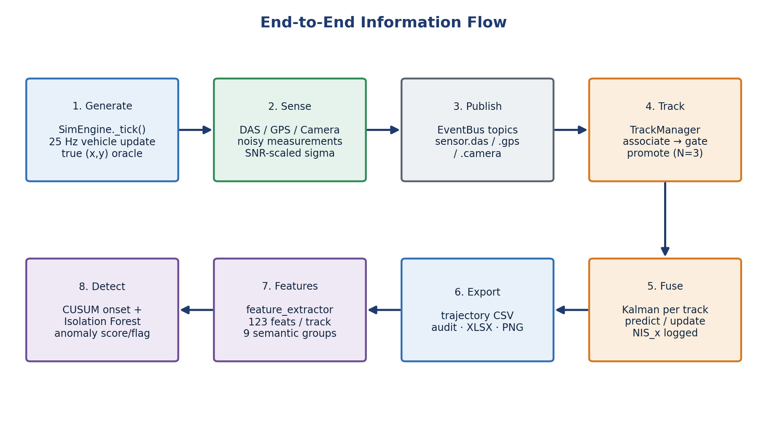
Figure 5: End-to-end information flow: generation, sensing, publication, tracking, fusion, export, feature extraction, and detection.
Generation. Every 25 Hz tick, the engine advances each vehicle's arc-length position along its lane, handles segment-to-segment transitions through the road graph, applies the lateral drift, and computes the vehicle's true world position. That true position is published as the ground-truth oracle, used later only for error measurement — never for estimation.
Sensing and publication. In the same tick, each sensor decides whether to fire and, if so, computes its measurement and physically derived uncertainty and publishes a typed event (sensor.das, sensor.gps, or sensor.camera) onto the event bus. Missed DAS detections publish a lightweight miss event instead, preserving an honest record of coverage gaps.
Tracking. The track manager consumes the sensor events and assigns each to a stable global track. Association is purely kinematic — the oracle vehicle identity in the payload is treated strictly as ground truth and is never used to associate. Each candidate track is scored by predicted-versus-measured distance plus speed, heading, and segment-adjacency penalties, inside spatial and temporal gates; the lowest-cost track wins. New tracks are born tentative and are promoted to confirmed only after three consecutive associated measurements, which suppresses spurious single-hit DAS ghosts.
Fusion. The Kalman filter runs as a post-tracking stage, replaying the same event stream grouped by track. For each track it alternates constant-acceleration prediction with measurement updates whose noise covariance R is set from the sensor's forwarded σ and further scaled by its confidence. All updates use the numerically stable Joseph form. After every update the filter logs the pre-update innovation and its variance, producing the Normalized Innovation Squared signal that the anomaly layer later consumes.
Export, feature extraction, and detection. Collected events are written to trajectories, the Excel workbook, the audit report, and per-track visualizations. The feature extractor reduces each vehicle's thousands of time-step rows to a single fingerprint of 166 features across nine semantic groups, and the scorer compares each fingerprint against the learned normal baseline while the CUSUM detector locates the onset of any inconsistency in time.

4.3 Communication and dependencies between modules
All inter-module communication flows through the event bus, which keeps dependencies acyclic and one-directional. The simulator depends on nothing downstream; the tracker depends only on the bus event schemas; the Kalman builder depends on the tracker's identity assignment; the export and audit modules depend on the fused rows; and the analytics package depends only on the files on disk. This strict layering was enforced as an explicit engineering rule and verified by tests, because it guarantees the read-only property of the analytics layer and lets each stage be replaced independently.

4.4 Ground-truth separation and data integrity
Because the project is based on simulation, it is essential to show that the anomaly model does not benefit from information a real deployment would not have. The anomaly-detection pipeline is strictly separated from the simulator's ground-truth generation layer. During scoring, the model does not consume oracle vehicle identity, injected anomaly labels, or ground-truth trajectories; it operates only on sensor-derived measurements and the quantities computed from them. Ground truth is used solely for evaluation — computing tracking RMSE and verifying whether the injected anomalous vehicle was correctly detected. This separation ensures that the reported results reflect observable, sensor-derived behavior rather than leakage from the simulator, and it is what allows the same pipeline to be applied unchanged to recorded real data.

4.5 Key algorithms and engineering decisions
SNR-driven dynamic measurement noise. Rather than hand-tuned constants, each sensor's uncertainty is computed from its physics at every measurement. For DAS the position standard deviation shrinks as the SNR improves and is then scaled by the measurement confidence before entering the filter as the noise covariance (Equation 7):
$σ_{DAS} = max\left(0.8, \frac{k_{DAS}}{\sqrt{SNR}}\right), R = \frac{σ^{2}}{conf}$ Equation 7
This means the filter trusts a heavy, nearby vehicle far more than a light, distant one — automatically and without manual tuning. The decision is what makes complementary fusion work: across DAS coverage gaps the filter relies on GPS and camera, and where DAS is strong it dominates by design (its measurement variance can be an order of magnitude smaller than that of GPS).
The ghost-track association fix. Early testing revealed an instructive failure: a well-tracked vehicle could acquire zero GPS measurements. High-rate DAS hits that fell just outside the gate spawned tentative ghost tracks with the same kinematics as the true track; when a sparse GPS fix arrived, the ambiguity guard saw two near-identical candidates and, rather than risk a wrong association, opened a new fragment track — orphaning the GPS data. The fix was to make the ambiguity guard identity-aware: only a second confirmed track can block an association, so transient ghosts are ignored and GPS flows into the correct confirmed track. The broader lesson is that in multi-rate sensor fusion, association logic must distinguish established tracks from provisional ones.
Innovation logging as the anomaly substrate. Logging the filter's innovation statistics turns the Kalman filter into a sensor of its own consistency. The Normalized Innovation Squared in the x-direction is the ratio of the squared pre-update innovation to its variance (Equation 8):
${NIS}_{x} = \frac{{ν_{x}}^{2}}{S_{xx}}$ Equation 8
Under a consistent, well-tuned filter this quantity follows a χ²(1) distribution with an expected value of one; a sustained rise indicates that reality has diverged from the model — the signature of an anomaly. Routing this signal into the CUSUM detector provides a principled, model-based temporal anomaly indicator.
Backward-compatible, test-guarded evolution. The pipeline grew through versioned stages, each preserving exact behavior on earlier scenarios. When the tracker was inserted in front of the Kalman filter, the one-to-one identity case was kept byte-identical so that no accuracy regression could pass unnoticed. A test suite spanning the simulator core, the Kalman filter, the tracker, and the export pipeline guards every signal the anomaly model depends on.

4.6 The anomaly model in detail
Figure 6 summarizes the anomaly-detection architecture. The key point is that the system separates temporal inconsistency detection from trajectory-level anomaly scoring. The model is realized in three layers. Layer 1 — feature extraction turns each vehicle's trajectory into a single 166-number fingerprint. Layer 2 — CUSUM watches the Kalman NIS over time and localizes when a deviation began. Layer 3 — the scenario scorer learns the normal fingerprint distribution and scores each vehicle by deviation.
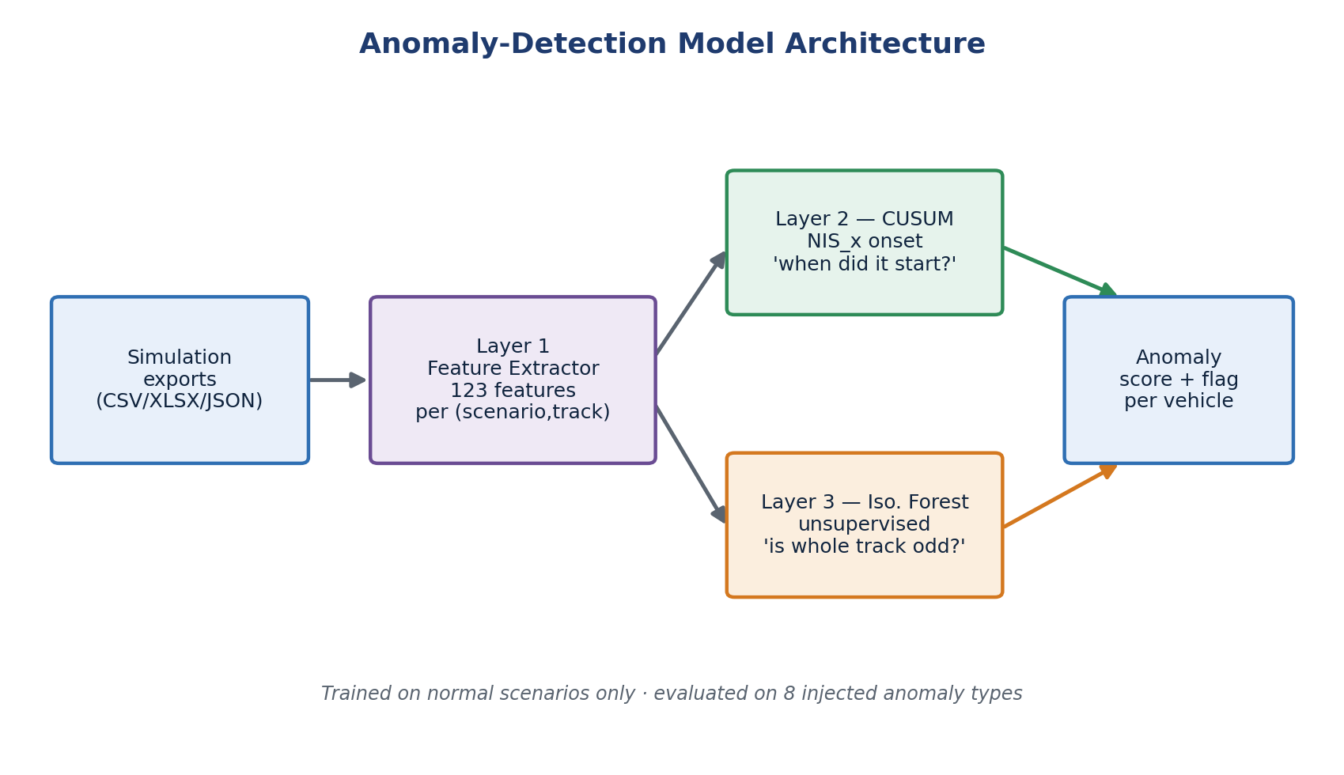
Figure 6: Anomaly-detection model architecture: feature extraction feeds a temporal CUSUM detector and a trajectory-level scorer, which combine into a per-vehicle anomaly score and flag.
Terminology and roles. To avoid ambiguity, the relationship between the model components is stated explicitly. The reported anomaly results are produced by the interpretable per-feature Z-score baseline. CUSUM is not the main trajectory-level classifier; it provides temporal localization of abnormal behavior [6]. The 166 features are organized into the nine groups shown in Table 2.
Why the Z-score baseline. The Z-score baseline was selected as the primary detector because it is fully interpretable: every anomaly flag can be traced back to the specific physical features that caused it (for example, an excessive mean speed or lateral velocity), which is essential for explaining a decision to an operator and for diagnosing failures. The Isolation Forest [7] is retained as an unsupervised alternative because it can capture multivariate feature interactions that a per-feature criterion may miss; however, it is less transparent, since its score does not isolate which features drove the decision. A supervised Random Forest is supported for future experiments once enough labeled anomaly data exists. In this project the interpretability of the Z-score baseline was judged more valuable than the additional modeling flexibility of the alternatives.
Feature group | # | Examples | Purpose
Sensor coverage & availability | 56 | per-sensor coverage, gaps, timing | Detect sensing gaps or unusual visibility
Kinematics (longitudinal & lateral) | 35 | speed, acceleration, jerk, lane offset, lateral velocity | Detect speeding, braking, reckless, weaving, straddling
Inter-vehicle / spacing | 20 | distance and time-to-collision to neighbors | Detect tailgating / collision-related behavior
DAS signal quality | 17 | SNR, amplitude, estimated weight | Detect overweight or unusual DAS response
Kalman quality | 13 | innovation, NIS, RMSE proxy | Detect prediction / measurement inconsistency
Inter-sensor disagreement | 11 | cross-sensor position / speed residuals | Detect inconsistent or spoofed measurements
Camera | 7 | detection confidence, range, off-axis angle | Detect visibility / occlusion effects
Audit & scenario context | 5 | track integrity flags, scenario parameters | Detect tracking faults; provide context
GPS | 2 | fix availability and uncertainty | Detect positioning gaps
Table 2: The nine feature groups produced by the feature extractor (166 features per vehicle in total).
The temporal layer uses Page's one-sided CUSUM, which accumulates the evidence that the current NIS exceeds a reference level k, and raises an alarm when the running statistic crosses a threshold h (Equation 9):
$S_{t} = max\left(0, S_{t−1} + \left({NIS}_{x} − k\right)\right)), alarm if S_{t} ≥ h$ Equation 9
The trajectory-level detector standardizes each feature against the learned normal mean and standard deviation and flags a vehicle when its largest absolute Z-score exceeds the decision threshold (Equation 10):
$z_{i} = \frac{x_{i} − μ_{i}}{σ_{i}}, score = \max_{i} |z_{i}|$ Equation 10

4.7 Repository structure
The deliverables are organized so that the simulator, the analytics layer, the maps, and the recorded outputs each occupy a clearly separated part of the tree. The abridged layout below highlights the components discussed above and the strict simulator / analytics separation that underpins the read-only design.
optical-fibers-smart-cities/
├── src/simstudio/ # Simulation engine + desktop editor
│ ├── sim_core.py # 25 Hz engine · vehicle physics · sensor models
│ ├── bus.py # EventBus (publish / subscribe)
│ ├── tracking.py # Cross-segment TrackManager (identity)
│ ├── kalman.py # 6-state CA fusion + row builders
│ ├── audit.py # Trajectory / audit exporter
│ ├── export_xlsx.py # Styled Excel workbook + charts
│ └── gui/app.py # Tkinter editor · geometry · models · config
├── anomaly_model/ # Read-only analytics (never imports simstudio)
│ ├── feature_extractor.py # Trajectory → 166-feature fingerprint
│ ├── cusum_detector.py # Temporal NIS_x onset detector
│ ├── scripts/scenario_scorer.py # Z-score · Isolation-Forest · RandomForest
│ ├── simulations/ # Normal + 9 injected-anomaly scenarios
│ ├── outputs/ # Feature tables · models · scores
│ └── docs/ # Anomaly-model flow + intel guide
├── maps/ # OpenStreetMap networks (Florentin · N. Tel Aviv)
├── scripts/ # run_app.py + batch pipeline helpers
├── outputs/ # Sample trajectories · audit reports · workbooks
├── tests/ # Pytest suite (sim · kalman · tracker · export)
├── docs/ # Physical-models & equations references
├── run_anomaly_pipeline.py # End-to-end anomaly pipeline entry point
└── README.md · CHANGELOG.md · pyproject.toml · install.sh

5 Analysis of Results
Results are organized around the project's evaluation questions and reported against the quantitative targets fixed in the work plan. Tracking and fusion accuracy are examined first, followed by sensor-fusion behavior, anomaly-detection performance, a failure analysis of the missed anomalies, and a consolidated comparison with the targets.

5.1 Tracking and fusion accuracy
Fusion accuracy was measured against the simulator's ground-truth trajectories using the position RMSE (Equation 11):
$RMSE = \sqrt{\frac{1}{N}Σ_{k}\left({\left({x̂}_{k} − x_{k}\right)}^{2} + {\left(ŷ_{k} − y_{k}\right)}^{2}\right)}$ Equation 11
In a representative cross-segment run, a vehicle tracked across the seg1→seg2 boundary while fusing all three sensors achieved a position RMSE of 0.49 m with a maximum instantaneous error of 1.52 m (Figure 7). The estimate follows the ground truth throughout, including across the segment transition; GPS fixes appear as green markers that gently correct the estimate between DAS coverage zones, as the fusion design intends. Across the nine anomaly-evaluation scenarios the mean per-track RMSE was 0.35 m (best 0.19 m, worst 0.45 m) — consistently sub-meter, and an order of magnitude inside the ±5 m tolerance implied by the position and speed targets.
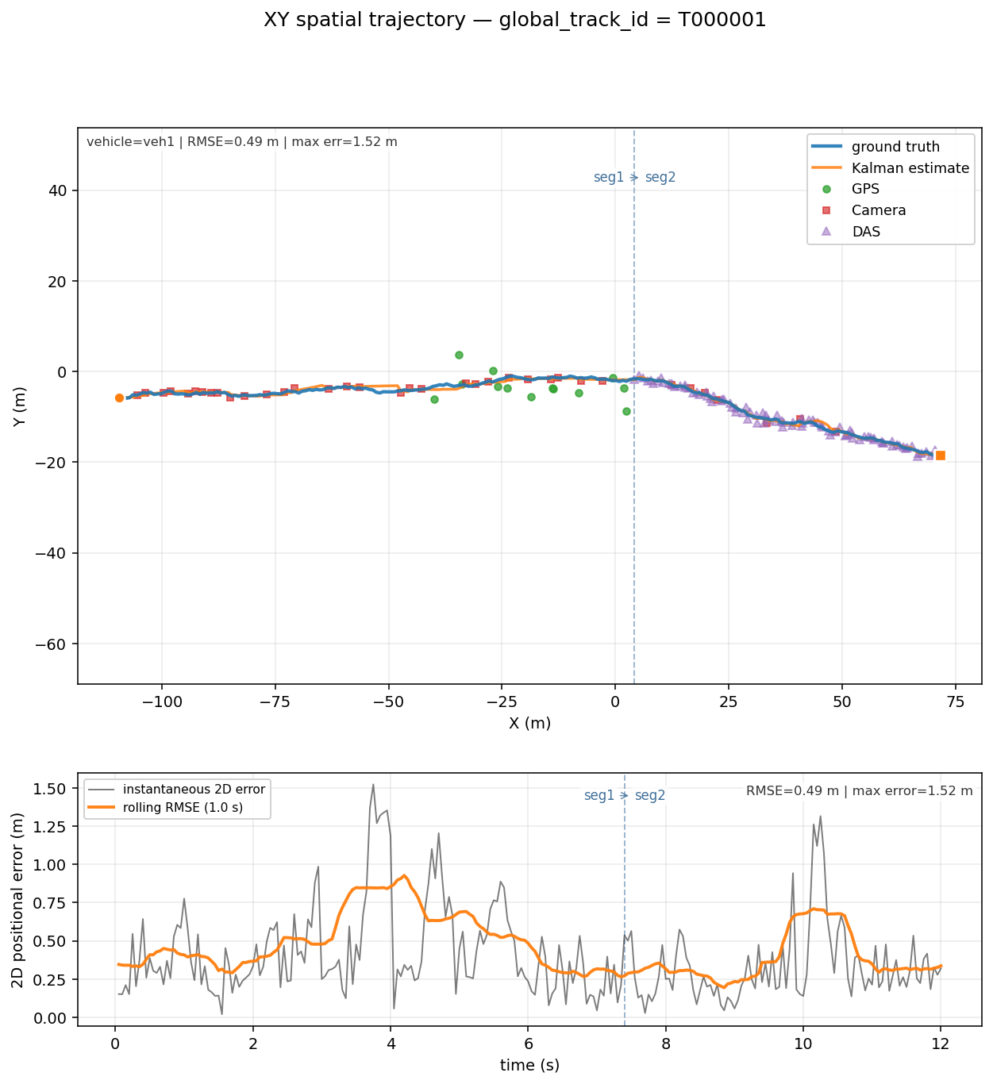
Figure 7: Fused multi-sensor track versus ground truth for a cross-segment vehicle. Top: spatial trajectory with DAS, camera, and GPS measurements; the dashed line marks the segment boundary. Bottom: instantaneous and rolling 2-D error (RMSE = 0.49 m, max 1.52 m).
The same behavior holds over longer routes. Figure 8 shows a vehicle tracked continuously across three connected segments in the over-speeding scenario, retaining a single identity through both transitions at 0.37 m RMSE (max 1.11 m) — confirming that the tracker scales beyond a single hand-off without fragmenting the trajectory.
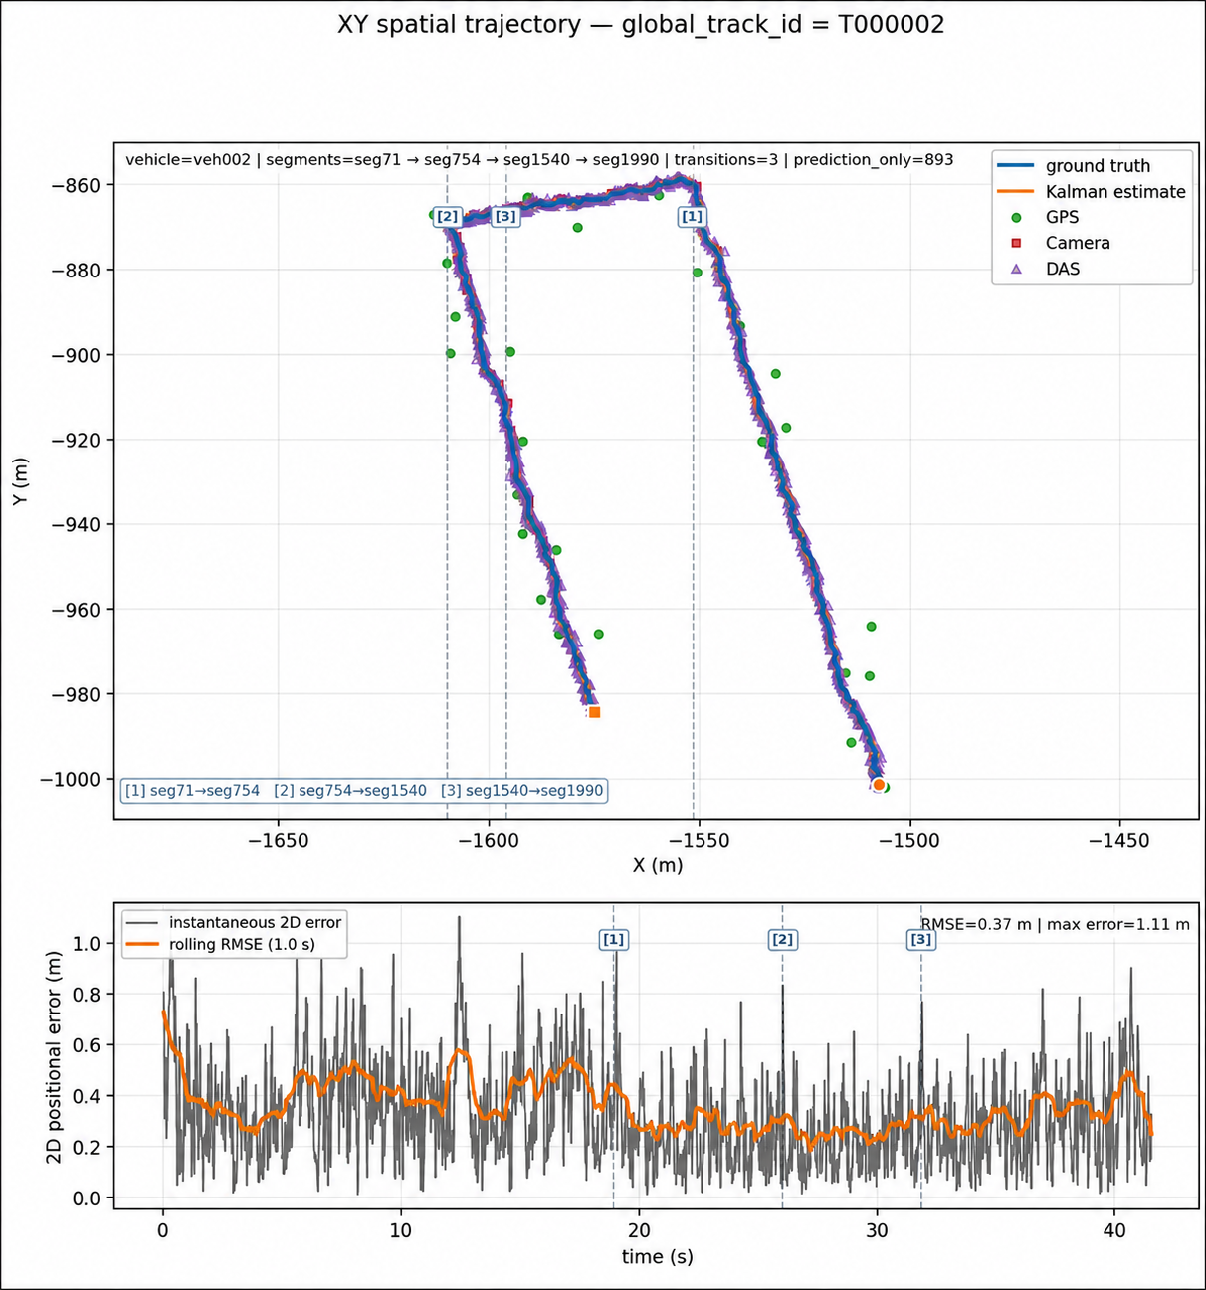
Figure 8: Continuous tracking across three connected segments (over-speeding scenario). Top: spatial trajectory with DAS, camera, and GPS measurements and two segment transitions; bottom: 2-D error over time (RMSE = 0.37 m, max 1.11 m).

5.2 Sensor contribution and fusion behavior
The accuracy above is a direct consequence of two design choices. The identity-aware association fix ensured that GPS measurements reached the correct confirmed track rather than orphan fragments, and the SNR-driven noise model let the filter weight each sensor by its physically derived reliability. In practice the three modalities play distinct roles: DAS provides the dense, high-rate backbone of the trajectory; the camera contributes accurate fixes at intersections; and GPS supplies low-rate absolute corrections that bound long-term drift between DAS coverage zones. Because DAS measurement variance can be roughly an order of magnitude smaller than that of GPS, the filter leans on DAS where it is strong and gracefully falls back to the other sensors where DAS is sparse — the intended complementary-fusion behavior.

5.3 Anomaly-detection performance
The anomaly model was trained on the behavioral fingerprints of roughly 150 normal scenarios — over fourteen thousand vehicle-tracks spanning twelve deliberately varied normal conditions. It was then evaluated on nine scenarios, each containing one injected anomalous vehicle drawn from eight anomaly categories (Table 3).
Anomaly scenario | Injected vehicle score (σ) | Detected?
Hard braking | 383.5 | Yes
Stalled vehicle | 376.1 | Yes
Collision | 315.6 | Yes
Reckless driver | 25.1 | Yes
Speeding | 21.6 | Yes
Overweight vehicle | 19.0 | Yes
Lane straddling | 6.2 | No
Lane weaving | 5.0 | No
Tailgating | 2.1 | No
Table 3: Anomaly-detection results across nine injected scenarios. Detection threshold ≈ 15.4 σ. The injected vehicle was correctly flagged in six of nine cases.
How the threshold was chosen. The decision threshold (≈ 15.4 σ) was selected from the normal baseline distribution in order to keep the false-positive rate low. A vehicle is flagged as anomalous only when its maximum per-feature deviation exceeds this conservative threshold, which sits well above the spread of normal vehicles and therefore favors precision over recall.
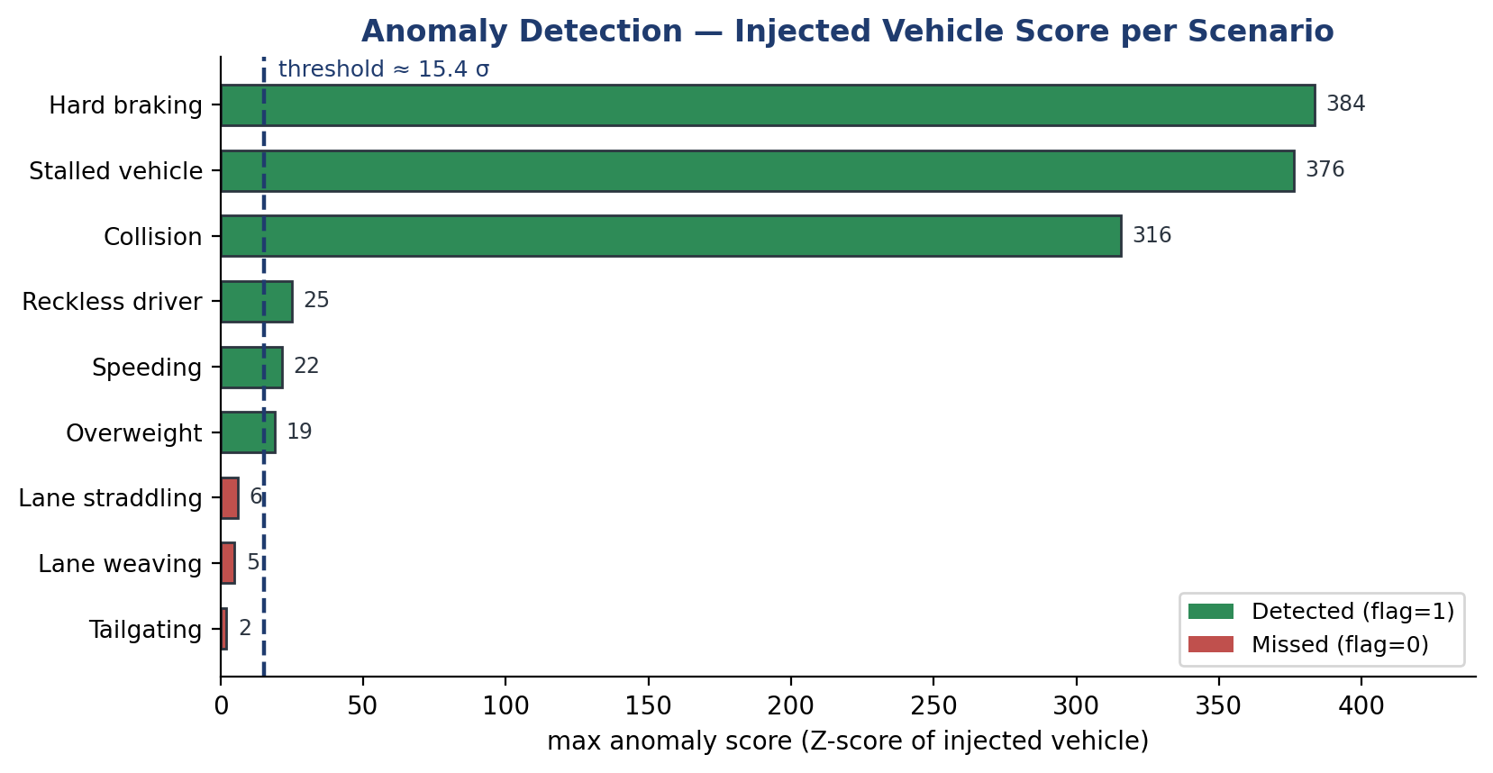
Figure 9: Anomaly score of the injected vehicle per scenario, against the ≈15.4 σ decision threshold. Longitudinal and sensor-level anomalies separate clearly from the normal baseline; subtle lateral and spacing anomalies do not.
The model correctly flagged the injected vehicle in six of the nine scenarios — speeding, hard braking, stalled vehicle, collision, reckless driving, and overweight vehicle. The work-plan target was at least five detections out of ten planned anomalies; the implemented evaluation covered nine injected scenarios, of which six were detected, so the target was met. Importantly, the detected set is not a random subset of the scenarios: these are precisely the anomalies with a strong physical signature — abnormal speed, sharp braking, prolonged stopping, elevated DAS amplitude, or Kalman inconsistency — which the feature-based, unsupervised model is well suited to capture. The separation is clear for the detected classes: scores of hundreds of sigma for braking, stalls, and collisions, and roughly 19–25 σ for the more subtle speeding, reckless, and overweight cases, all above the threshold while normal background vehicles remain low.
False positives. Across the evaluated anomaly scenarios, background vehicles generally remained below the decision threshold, with the only exceptions being vehicles physically affected by the stalled-vehicle or collision events, which are themselves forced to stop or brake abnormally and are therefore legitimately anomalous. The model is thus not simply over-flagging vehicles; its positives correspond to genuine behavioral deviations.
Examining a single scenario shows how a decision is reached. In the over-speeding case (Figure 10) the injected vehicle T000001 stands alone at 21.6 σ while the three background vehicles sit near 2 σ, well inside the normal band.
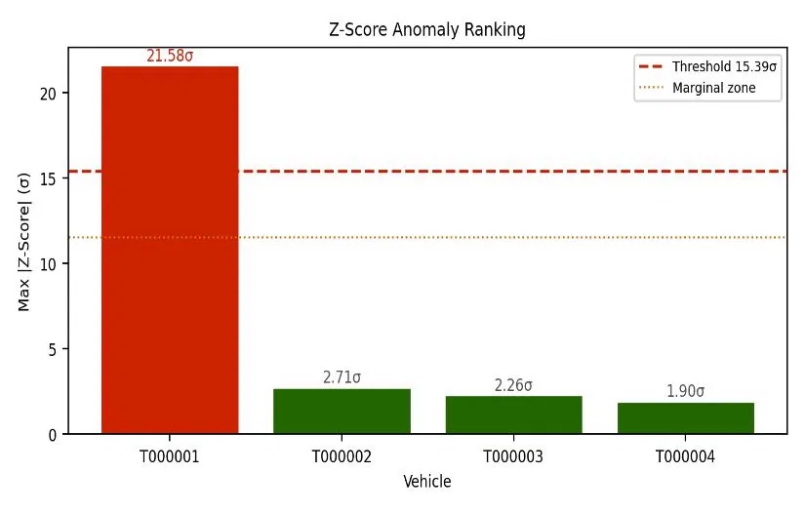
Figure 10: Per-vehicle Z-score ranking for the over-speeding scenario. The injected vehicle (red) exceeds the decision threshold by a wide margin; background vehicles (green) remain in the normal band.
The model is also interpretable: it reports which features drove each flag. Figure 11 overlays the injected vehicle's measured feature values on the normal training distributions, showing that its relative speed at closest approach, mean speed over the run, and lateral velocity all fall outside the normal range — the expected signature of over-speeding combined with aggressive lane use.
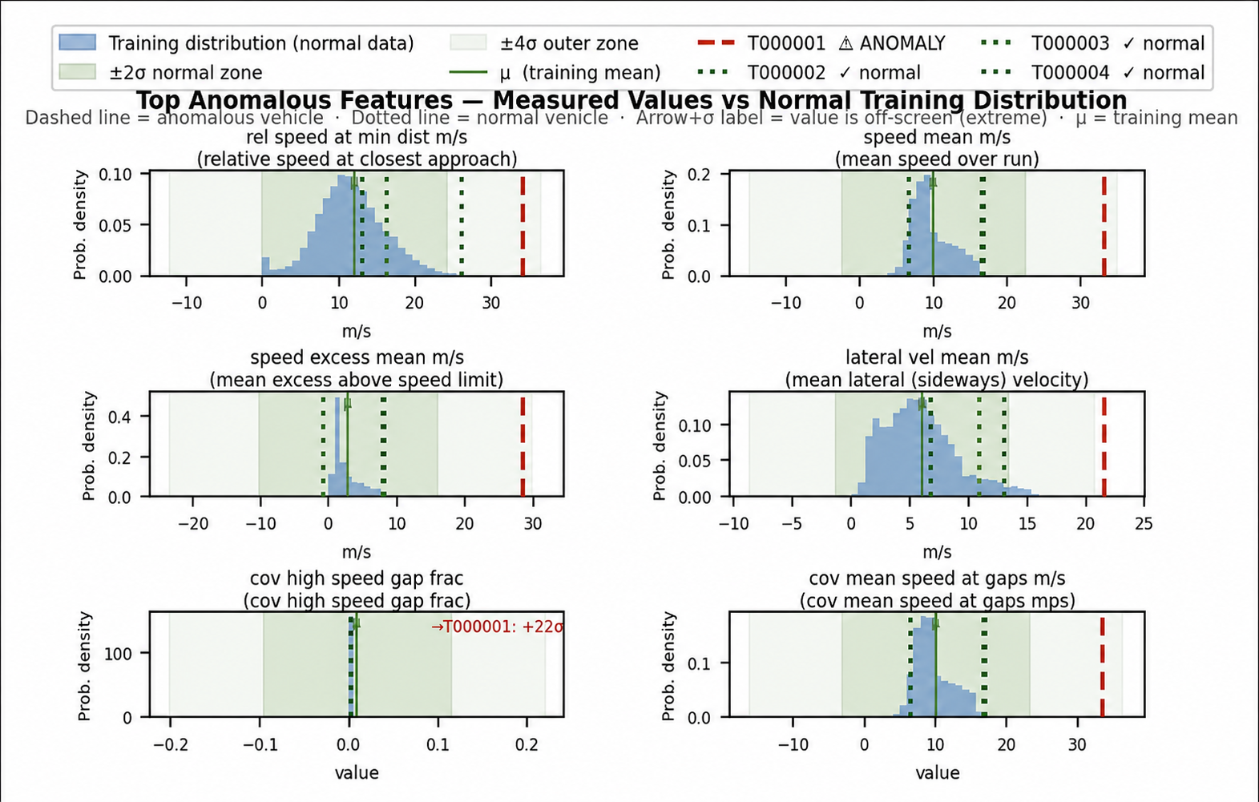
Figure 11: Top anomalous features for the injected vehicle versus the normal training distribution. Dashed lines mark the ±4 σ envelope; the vehicle's values (red) lie outside it on speed and lateral-velocity features, explaining the flag.

5.4 Missed anomalies and failure analysis
The model performs best on longitudinal and sensor-level anomalies — hard braking, stalled vehicles, collisions, speeding, reckless driving, and overweight vehicles — because these create strong deviations in speed, acceleration, Kalman consistency, or DAS amplitude. It performs less well on subtle lateral or interaction-based anomalies, namely lane weaving, lane straddling, and tailgating, which scored 5.0 σ, 6.2 σ, and 2.1 σ respectively and therefore fell below the conservative decision threshold.
This outcome is informative rather than a simple shortcoming. These behaviors remain close to the normal-driving distribution under the current feature set, especially because the threshold is chosen to avoid false alarms. The result directly identifies the next research direction: adding stronger lateral-dynamics and inter-vehicle-spacing features, fusing the CUSUM temporal signal into the trajectory score, and training the supported supervised Random Forest once enough labeled anomaly scenarios are available. In this sense the missed detections map out exactly where additional signal and labeled data would yield the largest improvement.

5.5 Comparison with quantitative targets
Table 4 consolidates the achieved results against the work-plan targets.
Target (work plan) | Goal | Achieved | Status
Cross-street tracking accuracy | ≥ 90% | Sub-meter RMSE (0.35 m mean, 0.49 m showcase) across segment boundaries | Met
Anomaly detection | ≥ 5 / 10 | 6 of 9 injected anomalies detected | Met
Kalman fusion success | ≥ 90% | Identity-aware association; confirmed-track fusion of all 3 sensors | Met
Position / speed tolerance | ≤ ±5 m | Max error 1.52 m; mean RMSE 0.35 m | Met
Simultaneous vehicles / segments | ≤10 / ≤5 | Multi-vehicle, multi-segment scenarios run routinely | Met
End-to-end latency | ≤ 60 s | Offline batch pipeline; real-time profiling pending | Partial
Table 4: Quantitative performance targets and achieved results.
Of the work-plan targets, the two primary objectives and the supporting accuracy targets were met; only end-to-end real-time latency remains to be profiled, as evaluation was conducted in an offline batch configuration suited to algorithm development.

6 Conclusions and Further Work

6.1 Results against the original goals
The project set two primary objectives in the Introduction, and the results map directly onto them. (1) Reliable cross-segment vehicle tracking was achieved at sub-meter accuracy — 0.49 m RMSE on a representative fused track and 0.35 m on average — with a single identity maintained across segment transitions. (2) Multi-sensor fusion of DAS, camera, and GPS was realized through physically derived, SNR-driven measurement uncertainty, allowing each sensor to contribute according to its reliability. (3) Anomaly detection from sensor-derived data flagged the injected anomalous vehicle in six of nine scenarios, meeting the at-least-five-of-ten target. Underpinning all three is a reproducible simulation environment that models the DAS measurement chain from vehicle weight to Kalman update, and a strictly read-only analytics layer that mirrors how a real deployment would operate on recorded data.

6.2 Suggestions to improve performance
The clearest opportunity is the three missed anomaly classes. With labeled anomaly scenarios now available, training the supported supervised Random Forest should improve sensitivity to subtle lateral and spacing anomalies that the unsupervised baseline cannot separate from normal variability. Adding explicit lateral-dynamics and inter-vehicle-spacing features, and fusing the CUSUM temporal signal directly into the trajectory score, would further raise recall while keeping the false-positive rate low. On the tracking side, replacing the kinematic association cost with a Mahalanobis-gated, covariance-aware association would improve robustness in dense traffic.

6.3 Future development and research
Three directions stand out. First, closing the loop to hardware: validating the simulator's physical models against real DAS recordings on an instrumented street, and profiling the pipeline in a streaming configuration to confirm the end-to-end latency target. Second, deepening the DAS physics — simulating the raw optical waterfall and signal-processing front end — so that event detection can be developed directly on channel data [2]. Third, scaling from neighborhoods to a city: extending cross-segment tracking to cross-street hand-off across many intersections, and surfacing fused trajectories and anomaly alerts on a live monitoring dashboard. Together these would carry the work from a validated simulation framework toward a deployable urban sensing system.

7 Project Documentation
All project deliverables are documented and version-controlled; this report describes them rather than reproducing code or data sheets.

7.1 Software
The software comprises two packages. The simstudio package contains the simulation engine, sensor models, event bus, track manager, Kalman fusion, export and audit modules, and the Tkinter desktop editor; it ships with an installable project definition, an install script, and a packaged macOS application. The anomaly_model package contains the feature extractor, the CUSUM detector, the scenario scorer (Z-score, Isolation-Forest, and supervised Random-Forest modes), and the batch extraction scripts. A test suite spanning the simulator core, Kalman filter, tracker, and export pipeline accompanies the code, together with a README, a changelog, a physical-models reference, and a validation protocol.

7.2 Simulations and datasets
The deliverables include the imported OpenStreetMap road networks (Florentin and northern Tel Aviv) with their sensor placements, roughly 150 normal-traffic scenarios spanning twelve conditions, and nine injected-anomaly scenarios covering eight categories. For each run the system produces trajectories, a styled Excel workbook, an audit report, and per-track visualizations; the anomaly layer produces per-vehicle feature tables and scored output files.

7.3 Documentation contents and location
Project documentation includes the user-facing README and install guide, the physical-models and equations references, the changelog tracking the versioned evolution of the pipeline, the validation protocol, and an anomaly-interpretation guide. The complete code base, documentation, simulation scenarios, and result datasets are maintained in the project repository (GitHub), whose link is provided with the submission.

8 References
[1] L. Hen, E. Lichtenstadt, K. Cohen, and A. Lellouch, “Enhanced Traffic Monitoring Using a Convolutional Neural Network with Video Signal as a Labels Producer over Fiber-Optic Seismology,” Tel Aviv University, 2023.
[2] K. Cohen, L. Hen, and A. Lellouch, “Training a Distributed Acoustic Sensing Traffic Monitoring Network with Video Inputs,” Tel Aviv University, 2023.
[3] “Exploring Cost-Effective Traffic Monitoring Through Kalman-Filter-Based Fusion of Fiber-Optic Seismology and Computer-Vision Tracking Data,” Tel Aviv University, 2023.
[4] N. Nissan and O. Nissan, “Automatic Calibration of DAS and Camera,” Tel Aviv University, 2023.
[5] R. E. Kalman, “A New Approach to Linear Filtering and Prediction Problems,” Journal of Basic Engineering, vol. 82, no. 1, pp. 35–45, 1960.
[6] E. S. Page, “Continuous Inspection Schemes,” Biometrika, vol. 41, no. 1–2, pp. 100–115, 1954.
[7] F. T. Liu, K. M. Ting, and Z.-H. Zhou, “Isolation Forest,” in Proc. IEEE Int. Conf. on Data Mining (ICDM), pp. 413–422, 2008.
[8] G. Welch and G. Bishop, “An Introduction to the Kalman Filter,” Tech. Rep. TR 95-041, University of North Carolina at Chapel Hill, 2006. Available: http://www.cs.unc.edu/~welch/kalman/
[9] OpenStreetMap contributors, “OpenStreetMap,” 2025. Available: https://www.openstreetmap.org

